Sorejevic Ana CR3.3A

**BAZA DE DATE**

**SALA DE EVENIMENTE**

1. Modelul ER entitate – legatura. Prezentarea entitatilor si a legaturilor dintre

acestea, impreuna cu cardinaliatea lor. Baza de date trebuie sa contina minimum 7

entitati.

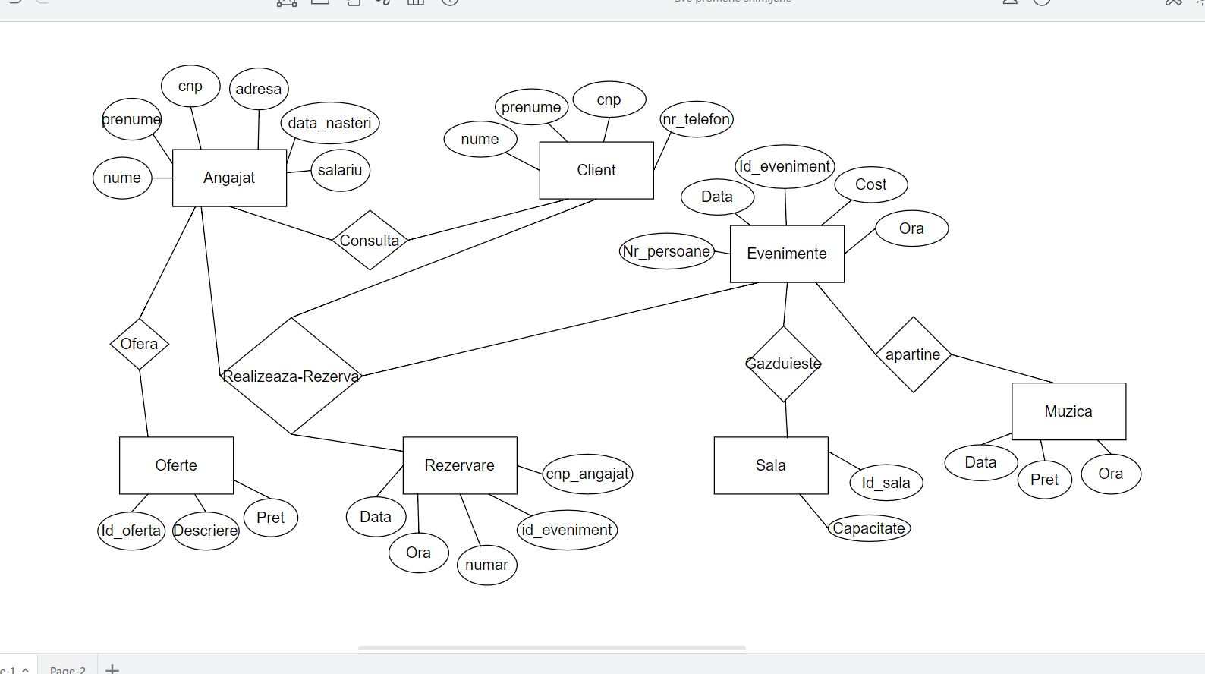

2. Schema relationala (stabilirea relatiilor, atributelor, cheilor primare, constrangerilor,

legaturilor dintre relatii - chei externe)

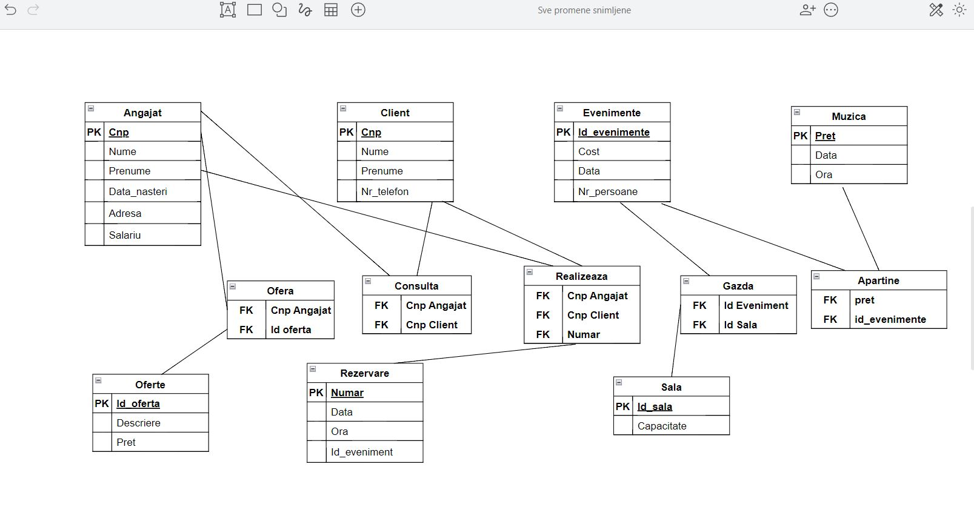

**Creare Tabele**

create table Angajat(

CNP varchar(13) not null,

Nume varchar (15) not null,

Prenume varchar(15) not null,

DataNastere date,

Salariu real,

Adresa varchar(25),

primary key(CNP)

);

Create table Client(

CNP varchar(13) not null,

Nume varchar(15) not null,

Prenume varchar(15) not null,

Nr_telefon varchar(10),

primary key (CNP)

);

Create table Evenimente(

Id_evenimente integer not null,

Cost_eveniment real not null,

Data_eveniment date not null,

Nr_persoane integer,

primary key (Id_evenimente)

);

Create table Oferte(

Id_oferta integer not null,

Descriere varchar(1000) not null,

Pret real not null,

primary key (Id_oferta)

);

Create table Rezervare(

Numar integer not null,

Data_rezervare date not null,

Ora time not null,

Id_eveniment integer,

Cnp_angajat varchar(13),

primary key (Numar)

);

Create table Sala(

Id_Sala integer not null,

Capacitate integer not null,

primary key (Id_Sala)

);

create table Realizeaza_Rezerva(

CNP_Angajat varchar(13),

CNP_Client varchar(13),

Numar integer

);

create table Ofera(

CNP_Angajat varchar(13),

Id_oferta integer

);

create table Consulta(

CNP_Angajat varchar(13),

CNP_Client varchar(13)

);

create table Gazda(

Id_Ev integer not null,

Id_Sala integer not null

);

Create table muzica(

pret_muzica real not null,

Data_muzica date not null,

Ora_muzica time not null,

primary key (Data_muzica)

);

create table Apartine(

Data_muzica date not null,

id_eveniment integer not null

);

**Creare Chei Externe**

-----Ofera-->>Angajat----

ALTER TABLE Ofera ADD CONSTRAINT

fk_cnp_angajat_cnp

FOREIGN KEY (CNP_Angajat )

REFERENCES Angajat(CNP);

-----Ofera-->>Oferte----

ALTER TABLE Ofera ADD CONSTRAINT

fk_Id_ofera_Id_oferta

FOREIGN KEY (Id_oferta )

REFERENCES Oferte(Id_oferta);

-----Consulta-->>Angajat---

ALTER TABLE Consulta ADD CONSTRAINT

fk_Cnp_angajat_Cnp

FOREIGN KEY (CNP_Angajat )

REFERENCES Angajat(CNP);

-----Consulta-->>Client---

ALTER TABLE Consulta ADD CONSTRAINT

fk_Cnp_Client_Cnp

FOREIGN KEY (CNP_Client )

REFERENCES Client(CNP);

-----Realizeaza_Rezerva-->>Angajat--

ALTER TABLE Realizeaza_Rezerva ADD CONSTRAINT

fk_Cnp_Cnp_Angajat

FOREIGN KEY (CNP_Angajat)

REFERENCES Angajat(CNP);

-----Realizeaza_Rezerva-->>Client--

ALTER TABLE Realizeaza_Rezerva ADD CONSTRAINT

fk_Cnp_Cnp_Client

FOREIGN KEY (CNP_Client)

REFERENCES Client(CNP);

-----Realizeaza_Rezerva-->>Rezervare----

ALTER TABLE Realizeaza_Rezerva ADD CONSTRAINT

fk_Numar_Numar

FOREIGN KEY (Numar)

REFERENCES Rezervare(Numar);

-----Gazda-->>Evenimente--

ALTER table Gazda ADD CONSTRAINT

fk_Id_Ev_Id_evenimente

FOREIGN KEY (Id_Ev)

REFERENCES Evenimente(Id_evenimente);

-----Gazda-->>Sala--

ALTER table Gazda ADD CONSTRAINT

fk_Id_sala_Id_sala

FOREIGN KEY (Id_Sala)

REFERENCES Sala(Id_Sala);

ALTER TABLE apartine ADD CONSTRAINT

fk_Id_evenimenta_Id_eveniment

FOREIGN KEY (Id_eveniment )

REFERENCES apartine(Id_eveniment);

ALTER TABLE apartine ADD CONSTRAINT

fk_data_data_muzica

FOREIGN KEY (data_muzica )

REFERENCES apartine(data_muzica);

**Inserare Date Tabel Angajati**

insert into Angajat(CNP,Nume,Prenume,DataNastere,Salariu,Adresa) values

(‘6000781005163’,

‘Popescu’,

‘Maria’,

‘06/08/1971’,

‘2850’,

‘str.24 ianuarie,Nr. 29’

);

insert into Angajat(CNP,Nume,Prenume,DataNastere,Salariu,Adresa) values

(‘6012781005163’,

‘Marinescu’,

‘Mara’,

‘09/08/1971’,

‘2890’,

‘str.24A,Nr. 32’

);

insert into Angajat(CNP,Nume,Prenume,DataNastere,Salariu,Adresa) values

(‘6200781005163’,

‘Pop’,

‘Ioana’,

‘07/08/1981’,

‘2550’,

‘str.Mihai Eminescu,Nr. 39’

);

insert into Angajat(CNP,Nume,Prenume,DataNastere,Salariu,Adresa) values

(‘6008781005163’,

‘Grigore’,

‘Sara’,

‘06/08/1571’,

‘2220’,

‘str.Primaverii,Nr. 5’

);

insert into Angajat(CNP,Nume,Prenume,DataNastere,Salariu,Adresa) values

(‘6009781005163’,

‘Vasile’,

‘Marcu’,

‘03/08/1971’,

‘2250’,

‘str.Gara,Nr. 4’

);

insert into Angajat(CNP,Nume,Prenume,DataNastere,Salariu,Adresa) values

(‘6012781505163’,

‘Ciontu’,

‘Claudia’,

‘06/07/1971’,

‘3550’,

‘str.1 decembrie,Nr. 8’

);

insert into Angajat(CNP,Nume,Prenume,DataNastere,Salariu,Adresa) values

(‘6070701005263’,

‘Motoc’,

‘Andra’,

‘06/12/1971’,

‘2870’,

‘str.5A,Nr. 76’

);

insert into Angajat(CNP,Nume,Prenume,DataNastere,Salariu,Adresa) values

(‘6005681005163’,

‘Draghici’,

‘Andreea’,

‘01/02/1854’,

‘2859’,

‘str.Cascadei,Nr. 45’

);

insert into Angajat(CNP,Nume,Prenume,DataNastere,Salariu,Adresa) values

(‘2000781005163’,

‘Nitescu’,

‘Laura’,

‘01/10/1961’,

‘2980’,

‘str.Pop,Nr. 3S’

);

insert into Angajat(CNP,Nume,Prenume,DataNastere,Salariu,Adresa) values

(‘5649781005163’,

‘Varia’,

‘Marinela’,

‘02/05/1999’,

‘3456’,

‘str.Soarelui,Nr. 42’

);

**Inserare Date Tabel Client**

insert into Client(CNP,Nume,Prenume,Nr_telefon) values

(‘5658781005163’,

‘Cristescu’,

‘Valeria’,

‘0786539921’

);

insert into Client(CNP,Nume,Prenume,Nr_telefon) values

(‘1258781005163’,

‘Codrescu’,

‘Larisa’,

‘0786538921’

);

insert into Client(CNP,Nume,Prenume,Nr_telefon) values

(‘5658321005169’,

‘Cercel’,

‘Daniel’,

‘0786579921’

);

insert into Client(CNP,Nume,Prenume,Nr_telefon) values

(‘5058081005163’,

‘Grigorescu’,

‘Carla’,

‘0782539921’

);

insert into Client(CNP,Nume,Prenume,Nr_telefon) values

(‘1658781005163’,

‘Florescu’,

‘Catalina’,

‘0786939921’

);

insert into Client(CNP,Nume,Prenume,Nr_telefon) values

(‘5650781505163’,

‘Dragomir’,

‘Andrei’,

‘0786439921’

);

insert into Client(CNP,Nume,Prenume,Nr_telefon) values

(‘3658781005163’,

‘Costache’,

‘Ion’,

‘0786529921’

);

insert into Client(CNP,Nume,Prenume,Nr_telefon) values

(‘5658781005100’,

‘Marancea’,

‘Mihai’,

‘0786039921’

);

insert into Client(CNP,Nume,Prenume,Nr_telefon) values

(‘5658781005003’,

‘Dadulescu’,

‘Roberta’,

‘0786799921’

);

insert into Client(CNP,Nume,Prenume,Nr_telefon) values

(‘5018781005163’,

‘Ludovic’,

‘Mara’,

‘0788539921’

);

**Inserare Date Tabel Evenimente**

insert into Evenimente(Id_evenimente,Cost_eveniment,Data_eveniment,Nr_persoane) values

(‘20’,

‘400’,

‘03/02/2021’,

‘30’

);

insert into Evenimente(Id_evenimente,Cost_eveniment,Data_eveniment,Nr_persoane) values

(‘135’,

‘420’,

‘03/02/2019’,

‘678’

);

insert into Evenimente(Id_evenimente,Cost_eveniment,Data_eveniment,Nr_persoane) values

(‘450’,

‘460’,

‘09/02/2021’,

‘87’

);

insert into Evenimente(Id_evenimente,Cost_eveniment,Data_eveniment,Nr_persoane) values

(‘240’,

‘760’,

‘03/07/2021’,

‘79’

);

insert into Evenimente(Id_evenimente,Cost_eveniment,Data_eveniment,Nr_persoane) values

(‘260’,

‘4080’,

‘08/02/2021’,

‘309’

);

insert into Evenimente(Id_evenimente,Cost_eveniment,Data_eveniment,Nr_persoane) values

(‘207’,

‘200’,

‘03/02/2017’,

‘456’

);

insert into Evenimente(Id_evenimente,Cost_eveniment,Data_eveniment,Nr_persoane) values

(‘70’,

‘460’,

‘07/02/2021’,

‘309’

);

insert into Evenimente(Id_evenimente,Cost_eveniment,Data_eveniment,Nr_persoane) values

(‘28’,

‘465’,

‘03/02/2024’,

‘378’

);

insert into Evenimente(Id_evenimente,Cost_eveniment,Data_eveniment,Nr_persoane) values

(‘40’,

‘407’,

‘03/07/2021’,

‘35’

);

insert into Evenimente(Id_evenimente,Cost_eveniment,Data_eveniment,Nr_persoane) values

(‘10’,

‘700’,

‘09/02/2021’,

‘37’

);

**Inserare Date Tabel Oferte**

insert into Oferte (Id_oferta,Descriere,Pret) values

(‘29’,

‘Speciala’,

‘360’

);

insert into Oferte (Id_oferta,Descriere,Pret) values

(‘45’,

‘Mare’,

‘3608’

);

insert into Oferte (Id_oferta,Descriere,Pret) values

(‘56’,

‘Mica’,

‘567’

);

insert into Oferte (Id_oferta,Descriere,Pret) values

(‘234’,

‘Promotie’,

‘12’

);

insert into Oferte (Id_oferta,Descriere,Pret) values

(‘467’,

‘Promotionala’,

‘879’

);

insert into Oferte (Id_oferta,Descriere,Pret) values

(‘86’,

‘Tichete’,

‘345’

);

insert into Oferte (Id_oferta,Descriere,Pret) values

(‘705’,

‘Cod’,

‘430’

);

insert into Oferte (Id_oferta,Descriere,Pret) values

(‘576’,

‘Extra’,

‘97’);

insert into Oferte (Id_oferta,Descriere,Pret) values

(‘189’,

‘Promotie_De_Vara’,

‘900’

);

insert into Oferte (Id_oferta,Descriere,Pret) values

(‘472’,

‘Cadou’,

‘6590’

);

**Inserare Date Tabel Muzica**

insert into Muzica (pret_muzica,data_muzica,ora_muzica) values

('2000',

'04/07/2015',

'20:00'

);

insert into Muzica (pret_muzica,data_muzica,ora_muzica) values

('1000',

'09/07/2015',

'23:00'

);

insert into Muzica (pret_muzica,data_muzica,ora_muzica) values

('3000',

'08/07/2015',

'13:00'

);

insert into Muzica (pret_muzica,data_muzica,ora_muzica) values

('1420',

'04/09/2019',

'18:00'

);

insert into Muzica (pret_muzica,data_muzica,ora_muzica) values

('2400',

'01/07/2015',

'11:00'

);

insert into Muzica (pret_muzica,data_muzica,ora_muzica) values

('750',

'04/02/2016',

'15:00'

);

insert into Muzica (pret_muzica,data_muzica,ora_muzica) values

('1320',

'08/07/2015',

'13:00'

);

**Inserare Date Tabel Rezervare**

insert into Rezervare(Numar,Data_rezervare,Ora,Id_eveniment) values

('365',

'04/07/2015',

'20:00',

'078'

);

insert into Rezervare(Numar,Data_rezervare,Ora,Id_eveniment) values

('165',

'09/07/2015',

'23:00',

'476'

);

insert into Rezervare(Numar,Data_rezervare,Ora,Id_eveniment) values

('980',

'04/06/2015',

'21:00',

'158'

);

insert into Rezervare(Numar,Data_rezervare,Ora,Id_eveniment) values

('748',

'08/07/2015',

'13:00',

'231'

);

insert into Rezervare(Numar,Data_rezervare,Ora,Id_eveniment) values

('47698',

'04/02/2016',

'15:00',

'88789'

);

insert into Rezervare(Numar,Data_rezervare,Ora,Id_eveniment) values

('3653',

'04/09/2019',

'18:00',

'07968'

);

insert into Rezervare(Numar,Data_rezervare,Ora,Id_eveniment) values

('3605',

'04/03/2015',

'22:00',

'0708'

);

insert into Rezervare(Numar,Data_rezervare,Ora,Id_eveniment) values

('3980',

'07/09/2013',

'02:00',

'07128'

);

insert into Rezervare(Numar,Data_rezervare,Ora,Id_eveniment) values

('36502',

'04/06/2015',

'12:00',

'07845'

);

insert into Rezervare(Numar,Data_rezervare,Ora,Id_eveniment) values

('42365',

'01/07/2015',

'11:00',

'078421'

);

**Inserare Date Tabel Sala**

insert into Sala(Id_sala,Capacitate) values

('200',

'34'

);

insert into Sala(Id_sala,Capacitate) values

('567',

'345'

);

insert into Sala(Id_sala,Capacitate) values

('987',

'123'

);

insert into Sala(Id_sala,Capacitate) values

('56778',

'90087'

);

insert into Sala(Id_sala,Capacitate) values

('3086',

'3477'

);

insert into Sala(Id_sala,Capacitate) values

('20780',

'3400'

);

insert into Sala(Id_sala,Capacitate) values

('20320',

'3411'

);

insert into Sala(Id_sala,Capacitate) values

('20340',

'3467'

);

insert into Sala(Id_sala,Capacitate) values

('9753',

'700'

);

insert into Sala(Id_sala,Capacitate) values

('890',

'5679'

);

**Inserare Date Tabel Realizeaza Rezerva**

insert into Realizeaza_Rezerva(CNP_Angajat,CNP_Client,Numar) values

('6000781005163',

'5658781005163',

'365'

);

insert into Realizeaza_Rezerva(CNP_Angajat,CNP_Client,Numar) values

('6012781005163',

'1258781005163',

'165'

);

insert into Realizeaza_Rezerva(CNP_Angajat,CNP_Client,Numar) values

('6200781005163',

'5658321005169',

'980'

);

insert into Realizeaza_Rezerva(CNP_Angajat,CNP_Client,Numar) values

('6008781005163',

'5058081005163',

'748'

);

insert into Realizeaza_Rezerva(CNP_Angajat,CNP_Client,Numar) values

('6009781005163',

'1658781005163',

'47698'

);

insert into Realizeaza_Rezerva(CNP_Angajat,CNP_Client,Numar) values

('6012781505163',

'5650781505163',

'3653'

);

insert into Realizeaza_Rezerva(CNP_Angajat,CNP_Client,Numar) values

('6070701005263',

'3658781005163',

'3605'

);

insert into Realizeaza_Rezerva(CNP_Angajat,CNP_Client,Numar) values

('6005681005163',

'5658781005100',

'3980'

);

insert into Realizeaza_Rezerva(CNP_Angajat,CNP_Client,Numar) values

('2000781005163',

'5658781005003',

'36502'

);

insert into Realizeaza_Rezerva(CNP_Angajat,CNP_Client,Numar) values

('5649781005163 ',

'5018781005163',

'42365'

);

**Inserare Date Tabel Gazda**

insert into Gazda(Id_Ev,Id_Sala) values

('10',

'200'

);

insert into Gazda(Id_Ev,Id_Sala) values

('135',

'567'

);

insert into Gazda(Id_Ev,Id_Sala) values

('450',

'987'

);

insert into Gazda(Id_Ev,Id_Sala) values

('240',

'56778'

);

insert into Gazda(Id_Ev,Id_Sala) values

('450',

'987'

);

insert into Gazda(Id_Ev,Id_Sala) values

('260',

'3086'

);

insert into Gazda(Id_Ev,Id_Sala) values

('207',

'20780'

);

insert into Gazda(Id_Ev,Id_Sala) values

('70',

'20320'

);

insert into Gazda(Id_Ev,Id_Sala) values

('28',

'20340'

);

insert into Gazda(Id_Ev,Id_Sala) values

('40',

'9753'

);

**Inserare Date Tabel Consulta**

insert into Consulta(Cnp_Angajat,Cnp_Client) values

('6000781005163',

'5658781005163'

);

insert into Consulta(Cnp_Angajat,Cnp_Client) values

('6012781005163',

'1258781005163'

);

insert into Consulta(Cnp_Angajat,Cnp_Client) values

('6012781005163',

'5658321005169'

);

insert into Consulta(Cnp_Angajat,Cnp_Client) values

('6009781005163',

'1658781005163'

);

insert into Consulta(Cnp_Angajat,Cnp_Client) values

('6009781005163',

'5650781505163'

);

insert into Consulta(Cnp_Angajat,Cnp_Client) values

('6070701005263',

'3658781005163'

);

insert into Consulta(Cnp_Angajat,Cnp_Client) values

('6005681005163',

'5658781005100'

);

insert into Consulta(Cnp_Angajat,Cnp_Client) values

('2000781005163',

'5658781005003'

);

insert into Consulta(Cnp_Angajat,Cnp_Client) values

('5649781005163',

'5018781005163'

);

insert into Consulta(Cnp_Angajat,Cnp_Client) values

('5649781005163',

'5018781005163'

);

insert into Consulta(Cnp_Angajat,Cnp_Client) values

('2000781005163',

'5658781005003'

);

**Inserare Date Tabel Ofera**

insert into Ofera(CNP_Angajat,Id_oferta)values

('6012781005163',

'29'

);

insert into Ofera(CNP_Angajat,Id_oferta)values

('6012781005163',

'29'

);

insert into Ofera(CNP_Angajat,Id_oferta)values

('6000781005163',

'45'

);

insert into Ofera(CNP_Angajat,Id_oferta)values

('6012781005163',

'56'

);

insert into Ofera(CNP_Angajat,Id_oferta)values

('6200781005163',

'234'

);

insert into Ofera(CNP_Angajat,Id_oferta)values

('6012781005163',

'86'

);

insert into Ofera(CNP_Angajat,Id_oferta)values

('6070701005263',

'705'

);

insert into Ofera(CNP_Angajat,Id_oferta)values

('2000781005163',

'189'

);

insert into Ofera(CNP_Angajat,Id_oferta)values

('2000781005163',

'467'

);

insert into Ofera(CNP_Angajat,Id_oferta)values

('5649781005163',

'576'

);

**Operatii de Update**

----update la tabela Angajat unde avem CNP=x setam Prenumele='Maricica'

update Angajat set Prenume='Maricica'

where CNP='6070701005263';

----update la tabela Client unde avem CNP=y setam Nr_Telefon='0787887129'

update Client set Nr_Telefon='0787887129'

where Cnp='5658781005163';

----update la tabela Eveniment unde avem Nr_Persoane>z setam Cost_eveniment='1000'

update Evenimente set Cost_eveniment='1000'

where Nr_Persoane>'400';

----update la tabela Consulta unde avem CNP_Client=aaa setam CNP_Angajat='bbb'

update Consulta set Cnp_Angajat='6000781005163'

where Cnp_Client='1258781005163';

**Operatii de Delete**

--Sterge toti Clientii care au Nr Telefon=’aaa’

DELETE FROM Client

WHERE Nr_Telefon='0099223344’;

----Sterge toti angajatii care au salariul mai mic de 2100'

DELETE FROM Angajat

WHERE Salariu<'2100';

--Sterge toate gazduirile care au Id_Sala<1000

DELETE FROM Gazda

WHERE Id_Sala<'1000';

--Sterge toti Clientii care au Numele Mihai

DELETE FROM Client

WHERE Nume='Mihai';

---Sterge toate Muzica care au pret>3000

DELETE FROM Muzica

WHERE pret_muzica>'3000';

Forma normală 1 (FN1)

**Ofera**

|  |  |
| --- | --- |
| CNP_Angajat | ID_Sala |
| 50034677843211 | 101,1002 |
| 50034227843211 | 100 |

Domeniul pentru atributul ID_Sala contine o multime de valori si nu este atomic. In acest caz, atributul va fi indepartat si se va crea o alta relatie Sala-CnpAngajat (CNP_Angajat, Id.)

Deoarece un angajat poate sa prezinte in oferta mai multe sali(id-sala) va fi necesar dupa normalizare sa avem relatia sala-Angajat unde va trebui sa se mentioneze doar un singur ID pentru sala.

Forma normală 4 (FN4)

|  |  |  |
| --- | --- | --- |
| ID_Oferta | Descriere | Pret |
| 101 | Sala Mare | 10000 |
| 200 | Sala Mica | 20010 |
| 1000 | Sala Pentru Nunti | 222222 |

Dependente multivaloare: ID_Oferta –›–› Descriere

ID_Oferta –›–› Pret

Avem o dependenta pentru Id_Oferta din partea Descrierii si Pretului.

**Interogari cu operatii de Jonctiune**

--Sa se afiseze clientii care au numarul de telefon si au facut rezervare.

select Nume,Prenume,Nr_Telefon from Client

c inner join Realizeaza_Rezerva rr on c.Cnp =rr.Cnp_Client

and c.Nr_Telefon='0786538921';

--Sa se afiseze angajatii care au realizat rezervari si au salariul mai mare decat .

select Nume,Prenume,Salariu from Angajat

a inner join Realizeaza_Rezerva rr on a.CNP =rr.Cnp_Angajat

and Salariu>'2800';

**Interogari care sa contina functii de agregare si Group by**

--Afisam Clientii dupa Nume

SELECT Client.Nume FROM Client

group by Nume;

--Afisam angajatii dupa Prenume,Nume si Salariu

SELECT Angajat.Prenume ,Angajat.Nume ,Angajat.Salariu FROM Angajat

group by Prenume,Nume,Salariu;

--Afisam Oferte dupa pret

SELECT oferte.pret FROM oferte

group by pret;

--Afisam Rezervare dupa data,ora

SELECT Rezervare.data_rezervare,Rezervare.ora FROM rezervare

group by ora,Data_rezervare;

--Afisam Sala dupa Capacitate

SELECT Sala.capacitate FROM sala

group by capacitate;

SELECT MAX(oferte.pret) FROM oferte

group by pret;

SELECT angajat.Nume, AVG(salariu) FROM angajat

group by nume;

SELECT Evenimente.data_eveniment,SUM(Evenimente.Cost_eveniment) FROM Evenimente

group by data_eveniment;

**Exemple de subinterogari**

--Selectam Nume si Prenume din angajati unde salariul este mai mic

--decat salariul angajatului cu CNP-ul dat

select Nume,Prenume from Angajat where Salariu<all

(Select Salariu from Angajat where CNP='6012781005163');

--Selectam toti angajati unde salariul intre 2 numere

SELECT *FROM Angajat

WHERE Salariu Between 2500 and 3000;

--Selectam toti Clientii care au prenumele dat i

SELECT *FROM Client

WHERE Cnp in(select Cnp where Prenume='Larisa');

--Selectam Ofertele care au pretul mai mic decat 800

SELECT *FROM Oferte

WHERE Pret <any(select Pret from Oferte where Pret<'800');

--Selectam Angajatii care au salariu mai mic orice salariu aflat intre 2500 si2800

SELECT *FROM Angajat

WHERE Salariu <any(select Salariu

from Angajat where Salariu between 2500 and 2800);

--Afisam nume si prenume al clientului

-- daca a facut rezervarea cu numarul dat

SELECT Nume,Prenume FROM Client c

WHERE EXISTS

(SELECT * FROM Realizeaza_rezerva rr

WHERE rr.Cnp_Client = c.Cnp AND Numar ='365' );

-- Afisam angajatii cu numele Popescu

SELECT *

FROM Angajat

WHERE Nume IN('Popescu');

**Utilizarea a cel puțin 2 funcții pe șiruri de caractere, 2 funcții pe date**

**calendaristice, a funcțiilor NVL și DECODE, a cel puțin unei expresii CASE.**

select *

from Angajat

where DataNastere =’ 07/08/1981’

SELECT UPPER(nume),upper (prenume)

FROM client

SELECT nume, prenume

FROM angajat

WHERE LENGTH(Nume) > 5 and length(prenume) < 4

select *

from Angajat

where DataNastere<’ 07/08/1981’

SELECT DataNastere,Nume

FROM Angajat

Where DataNastere BETWEEN '07/08/1981' AND '09/08/1971';

SELECT Nume, Adresa

From Angajat

ORDER BY

(CASE

WHEN ADRESA='str.Pop,Nr. 3S'THEN Nume

ELSE Adresa

end);

SELECT Nume, nr_telefon

From Client

ORDER BY

(CASE

WHEN nr_telefon='0786039921'THEN Nume

ELSE nr_telefon

end);

**Vederi**

create view vedere_client as select Prenume, Nume

from client order by Prenume;

select * from Vedere_client;

create view vedere_Eveniment as select Cost_eveniment, Nr_persoane

from evenimente order by Cost_eveniment;

select * from Vedere_Eveniment;

create view vedere_Rezervare as select Numar, Data_rezervare, Ora

from rezervare order by Data_rezervare;

select * from Vedere_Rezervare;